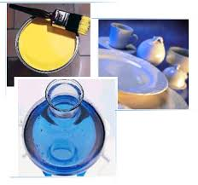**Glass:**  Feldspar is an important raw material for glass making. The alkali content in feldspar lowers the glass melting temperature and so reduces the production costs. A number of modern glass products can be obtained from it as shown below.

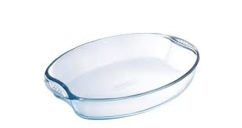

**Ceramics:** In the manufacture of ceramics, feldspar is the second most important ingredient after clay. Feldspar improves the strength, toughness, and durability of the ceramic body, and cement the crystalline phase of other ingredients, softening, melting and wetting other batch constituents.

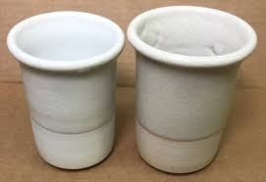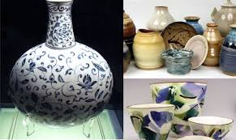



**Fillers:** Feldspars also are used as fillers and extenders in applications such as paints, plastics and rubber.  Beneficial properties of feldspars include good dispersability, high chemical inertness, stable pH, high resistance to abrasion, low viscosity at high filler loading, interesting refractive index and resistance to frosting.

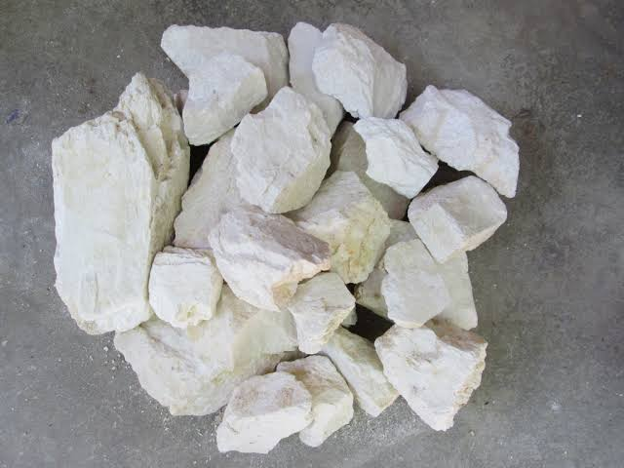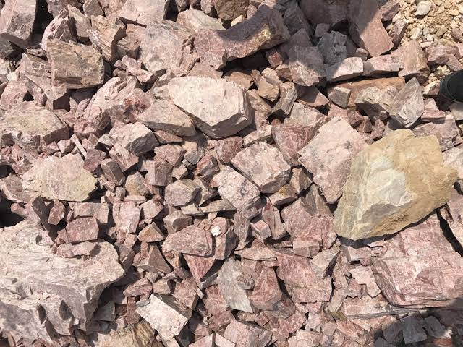

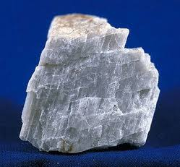

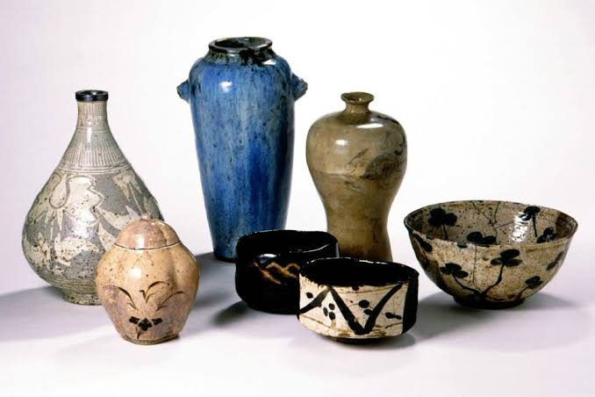**Enamel frits and glazes:** Feldspar assists the enamel composition, assuring the absence of defects and the neatness of the end product: e.g. enamel frits, ceramic glazes, ceramic tile glazes, sanitary ware, tableware, electrical porcelain and giftware.

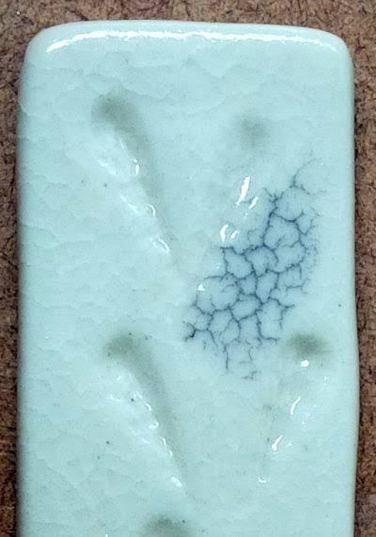

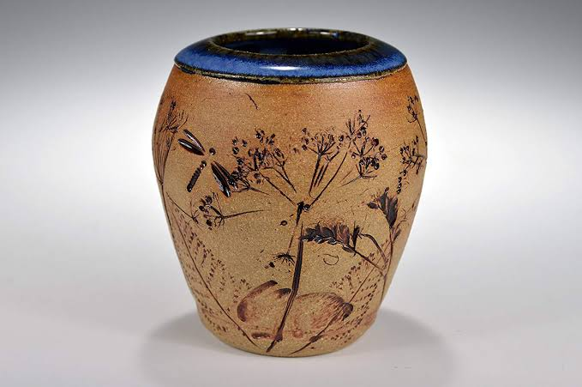

**Paints abrasives and coats:**paint, mild abrasives, urethane, welding electrodes (production of steel), latex foam, the welding of rod coating, and road aggregate.







**Tiles and flooring:** In the flooring sector, feldspar is the main constituent in the body composition.  It is used as a flux, lowering the vitrifying temperature of a ceramic body during firing and forming a glassy phase.

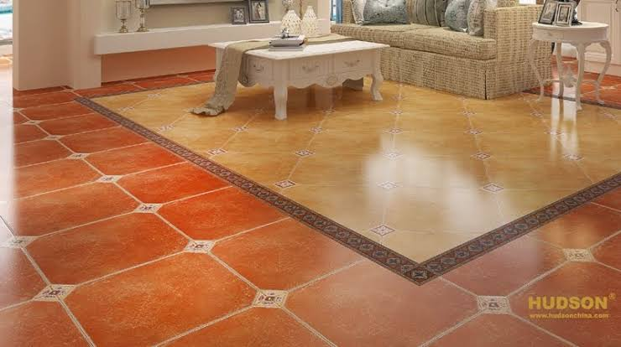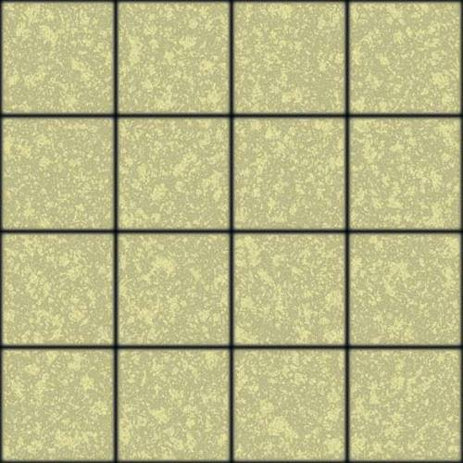

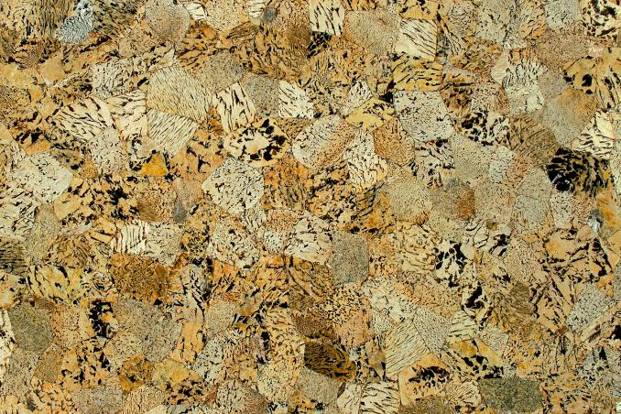

**Tableware**: In tableware, feldspar gives a good fusibility for a product without defects.

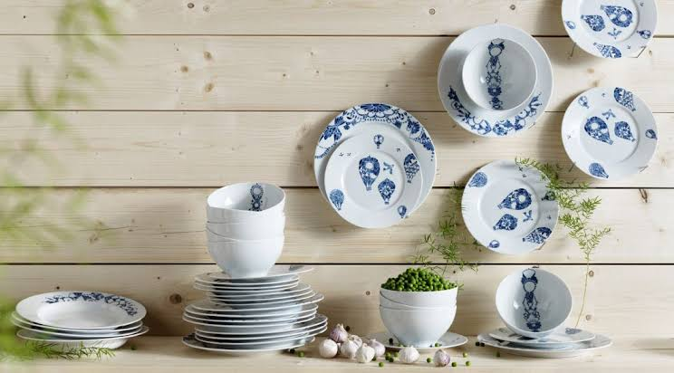

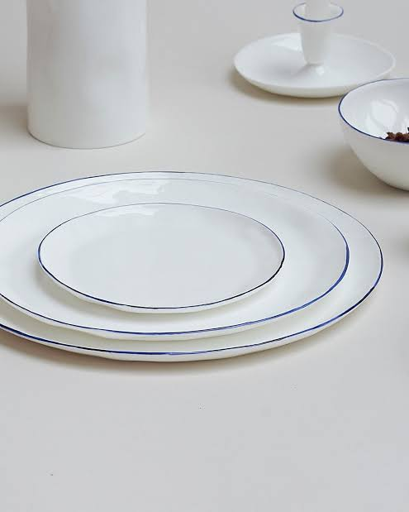

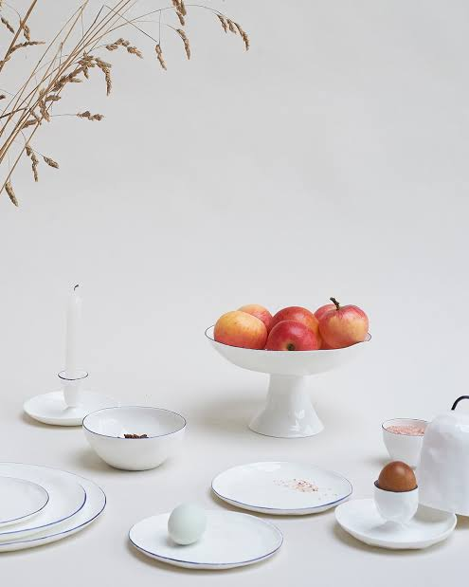

**In** **sanitary ware:** The use of feldspar within vitreous ceramic bodies is used to facilitate the optimization process.

